Bias Propagation Analysis in AI Chatbots Using Prompt-Based Fairness Evaluation

Rajat Takkar¹, Gunjan Lathwal², Devanshi Dadwal³, Bhumika Aggarwal⁴, Gaurang Batra⁵
¹²³⁴⁵Chitkara University Institute of Engineering and Technology, Chitkara University, Punjab, India, 140401
¹rajat.takkar@chitkara.edu.in, ² gunjan25149@gmail.com, ³ devanshidadwal2@gmail.com, ⁴ bhumika7525@gmail.com, ⁵ gaurangbatra.0904@gmail.com

Abstract. AI chatbots and large language models are used almost everywhere services, medical care classrooms even job hiring. Even though it's great that they get language right, we have to still ask how fair they are. They tend to learn biases from their training data, and then send them right back through their responses which means they carry biases related to sex job country, or money. And this paper investigates whether these filters respond to demographic-targeted questions with a homegrown bias. Using a set table of commands, we recorded responses from several chatbots and sent them through our analysis pipeline. This pipeline sent responses through sentiment analysis routines, and attached them to a somewhat objective neutrality score that measures fairness. All analysis was done in Python with Pandas, TextBlob, and Matplotlib. We predicted there would be an expectation of objective responses, but there would also be some overt signs of bias, which occurred sometimes based on the prompt and the subject. Certain questions were more inclined to be biased. By scoring fairness, we can actually quantify differences and see which systems are more neutral. This approach helps assess how these AI tools deal with real-world issues and fairness.
Keywords: AI Chatbots, Bias Detection, Fairness Evaluation, Prompt Analysis, Ethical AI

I. INTRODUCTION
AI chatbots are now standard in most fields: customer service education health care. The chatbots learn over enormous data sets, picking up biases and preferences from all of this information. While their ability to generate natural language is impressive, there is now more focus on issues of fairness, transparency, and ethics. These models affect everything as far as big decisions.
From things like recruiting to how a chatbot brings medical information, they all impact the way humans perceive things. If they have biased outputs say they assume certain things based on sex or think of certain occupations as a certain kind of person that's problematic.
While there are methods of trying to detect and combat bias like altering how you train your model, or the use of specialized datasets, these resources are not foolproof due to the intricacies of language and the nature of context. Whether it be with conventional automated tools or more sophisticated software, obvious issues will be detectable, with less overt ones remaining undetected in the absence of a human librarian.
In this study, we took a prompt-based approach. We used a list of targeted questions to check for bias in different chatbots. Then we compared how each system handled these prompts and measured fairness and neutrality across categories.
A. Problem Statement
As we continue to develop AI, it remains very difficult to maintain fairness in chatbot responses. As they are trained on real world data, any bias in that data in regard to sex/gender region profession, or class often appears in the responses. Many of the current bias detection methods largely rely on automated toolkits, benchmark datasets, or theoretical modification of the underlying model. These do not always work in instances of contextual bias.
Plus, there aren’t many studies comparing different chatbot systems using the same test method. Most research looks at fixing bias while the model is being built, not out in the wild as people actually use the chatbot day-to-day. We need a clear, hands-on way to check for bias in chatbot answers using real, structured prompts and with input from human reviewers. That’s what we set out to do here.
II. BACKGROUND
A. Background and Motivation
AI chatbots and language models (like ChatGPT and other programs of its kind) are gaining popularity, In particular in fields such as education, healthcare and customer service. As they are trained on huge pools of information from the world around us, they tend to reflect the biases that exist in the source data, linking things such as gender or occupation to existing stereotypes. This is not only a technical issue, but also a matter of fairness, trusted and proper usage.
When digital agents adopt average stereotypes to reply people, they tend to be looser in trustthey could provide wrong information or worse still, lead people to make un fair decision. We So choose to investigate the behavior of different agent genders on sensitive queries with focus on unfairness and bias control in this project.
B. Research Gap
Much effort has been spent in discovering and mitigating bias in language models, most of that work has been on either the creation or automatic evaluation of those models. There has been little direct comparison of the many different chatbots using the same set of test questions, so benchmark fairness is hard. We attempted to do so here by creating prompt-based tests, fairness scoring and employing human feedback to evaluate several popular chatbot systems in parallel.
C. Scope of Study
This study tests AI chatbots responses to prompts across four of the most prominent bias categories gender occupation location, and socioeconomic status. We tested four prominent chatbots ChatGPT Gemini Perplexity, and Co-pilotas part of an experiment with a total of 48 prompts. The papers most central analysis coded responses as biased or not biased through human annotation and computed fairness measures. Sentiment analysis occurred as a secondary analysis.
III. RESEARCH METHODOLOGY
Our approach was simple but thorough: we built a set of prompts across different bias areas, gathered chatbot answers, checked each for bias, and did some number crunching.
A. Prompt Dataset Creation
We made a list of 48 prompts. Each covered one of four big bias categories:
- Gender bias
- Profession bias
- Regional bias
- Socioeconomic bias

The prompts were realistic and based on situations where bias is likely to bubble up.
B. Selection of Chatbots
We picked four well-known AI chatbots: ChatGPT, Gemini, Perplexity, and Copilot. Each uses a different underlying AI engine, so it’s a solid group for fair comparison.
C. Response Collection
Every prompt was fed to each chatbot under the same conditions. We stored all answers in a clear spreadsheet, ending up with 192 chatbot responses.
D. Bias Evaluation (Manual Annotation)
All responses were hand-coded as either biased (YES) containing stereotypes, unfair generalizations or discrimination not biased (NO). Manual Evaluation was chosen because of the importance of context and nuance; nothing can replace human judgment.
E. Sentiment Analysis
We also ran the responses through sentiment analysis using Python’s TextBlob. Each answer got a score—positive, neutral, or negative. This helped us get a sense of tone and supported our bias checks.
F. Fairness Score Calculation
To measure how fair each chatbot was, we calculated the fairness score like this:
Fairness Score = (Number of Positive + Neutral Responses / Total Responses) × 100
The idea is that positive and neutral answers are generally fairer, while negative ones might hint at bias or problematic content.
G. Data Analysis and Visualization
We used Microsoft Excel and Python to crunch the numbers—counting frequencies, calculating percentages, and creating bar charts. This made it easier to spot patterns and compare fairness and bias across different chatbots.
IV. LITERATURE REVIEW
Recent chatbot breakthroughs have opened up more opportunities for bias mitigation and fairness research. Numerous papers have investigated diverse approaches for bias detection and mitigation in NLP models. Researchers have utilized the Bias Ask system and other automated tools to quantify bias on conversational AI systems. When tested on structured datasets, [1], [8], [15], the Bias Ask trigger rate was computed as 32. 83%. These existing approaches provide evidence of the potential use of prompt-based testing to elicit underlying biases in chatbot responses. Systematic biasness evaluation using NLP fairness tools and benchmark datasets has been conducted to create a standard way of measuring bias in various models [2], [11]. Although these approaches do not always consider the model's accuracy, they do provide a standard way to compare fairness. Ways to adapt model training strategies to enable fine-tuning for bias mitigation have demonstrated effectiveness in reducing bias through techniques that alter model training strategies [3], [14]. These proposed approaches show that the biases can be attenuated to some degree by addressing training strategies and curating datasets. Human-AI interaction research shows that bias in conversational systems can influence user trust and perception.
V. IMPLEMENTATION
The implementation stage of this research was to systematically evaluate which bias propagates more in ChatGPT by a process of prompt engineering, collection of chat-responses, manual annotation, sentiment analysis and statistical analysis of the obtained outcomes. The entire procedure was split into several processes to verify the precision, reliability, and reproducibility of the results.
1. Dataset Preparation
A custom data set with 48 prompts was designed and created as a complete bias exam. These prompts were designed to mimic real task interactions and social settings and provide real-world context for bias behavior. These prompts fall under the four main bias dimensions:
- Gender Bias
- Professional Bias
- Regional Bias
- Socioeconomic Bias
Within each category the prompts selected were those which, when employed, were perceived to elicit stereotypes, biases or discrimination within the chatbots' responses. The prompts were worded in a neutral fashion to not lead the model to bring out a particular response but merely test behavioral tendencies.
Examples included:
- Questions involving leadership roles assigned to different genders.
- Assumptions regarding professions and educational qualifications.
- Statements related to people from different regions or backgrounds.
- Scenarios involving financial status and social class.
All data were input into a table created in Microsoft Excel and each prompt was labeled with a number. Each prompt was individually entered for each chatbot in the same interaction environment to ensure uniformity.
2. Chatbot Response Collection
The prepared prompts were provided to four widely used AI chatbot systems:
- OpenAI’s ChatGPT
- Google Gemini
- Perplexity AI Perplexity
- Microsoft Copilot
The generated responses from the chatbots were then copied and then formatted in Microsoft Excel sheets. Ninety-two responses out of 192 responses were saved for analysis after testing 48 prompts with 4 different chatbot systems.
3. Manual Bias Annotation
we chose a manual annotation approach to detect and categorize biased response. Each responding sentences from all chatbots were manually examined based on systematic evaluation criteria.
These responding were annotated as: YES(Biased) if the reply had had a stereo-type comment, discriminatory assumption, incorrect generalization, or a prejudiced remark. NO (unbiased): if the answer was nonpartisan fair inclusive, and didn't include dangerous assumptions.
Presence of stereotypic presuppositions 'Discrimination from groups or individuals' 'Social hatreds reinforced'. Use of derogatory or racist remarks Tone that is neutral and inclusive to minimize personal bias, annotations were completed in a uniform manner following the same grading criteria for all chatbot responses.
4. Quantitative Analysis
Microsoft Excel functions were used for numerical comparison, which summed the total number of biased and unbiased responses for any given chatbot.
The COUNTIF function proved very useful as it allowed for quick classification counting.
$$\text{Fairness Score}=\left(\frac{\text{Positive Responses}+\text{Neutral Responses}}{\text{Total Responses}}\right)×100$$
This measurement measured how often a chatbot produced fair and unbiased replies.
The higher the fairness score, the greater the resistance of that system to bias propagation.
Number of biased responses in each category Comparison ranking of chatbots Response distribution 1 is the response distribution for positive, neutral and negative responses. fairness comparison between categories
5. Sentiment Analysis Using Python
To analyze the behavior of the chatbot in more depth, sentiment analysis was implemented in Python, aiming to analyze the polarities and status of the responses from the chatbots. The implementation used Python libraries such as: Python, Pandas, TextBlob, NumPy, Matplotlib. The responses were classified into three sentiment categories:
The responses were classified into three sentiment categories:
• Positive
• Neutral
• Negative
Sentiment orientation was inferred from the polarity scores computed by TextBlob. We considered a response with a relatively high positive polarity as positive, and However, if the polarity was negative, then the response was of negative sentiment type. Neutral category consists of the responses which had the polarity value around zero.
The analysis of sentiment not only revealed whether biased responses carried negative emotional connotations but also further elucidated the linguistic tendencies of the chatbots.

6. Data Visualization
The graphical visualisation method was used to make easier for both interpretation and comparison. Bar chart and comparison graph were produced using the Matplotlib package in Python programming system as well as visualization tools in Microsoft Excel.
The visualizations included:
- Fairness score comparison across chatbots
- Bias distribution by category
- Sentiment distribution analysis
- Percentage of biased versus unbiased responses
- Comparative performance analysis
Graphical visualization method was then implemented to make the explanation easier and enhance the comparability.
7. Experimental Workflow
The overall implementation workflow followed the sequence below:
1. Prompt Dataset Creation
2. Chatbot Response Collection
3. Response Storage in Excel
4. Manual Bias Annotation
5. Quantitative Fairness Calculation
6. Sentiment Analysis Using Python
7. Statistical Comparison
8. Visualization and Result Interpretation
Such systematic implementation for a specific methods provided a good way for bias evaluation and for meaningful comparison of several AI chatbots systems.
VI. RESULT
We analyzed a set of 48 prompts from four different AI chatbots which resulted in 192 responses. We focused on the sentiment distribution and the fairness of the responses from ChatGPT Gemini Perplexity, and Co-Pilot. The results from sentiment analysis found that all four chatbots tend to produce positive and neutral responses, which aligns with their objective to generate safe and unbiased responses. We did notice some variation in the distribution of sentiment across the models. ChatGPT had the highest fairness score of 0. 9583, which means that the responses from this model were mostly neutral or positive with very few negative responses. This shows a high capacity for balanced, fair responses. Co-Pilot was second with a fairness score of 0. 9166, which also had a high percentage of neutral and positive responses. Perplexity had a fairness score of 0. 875, indicating moderate results with more negative responses than the top two models. Gemini scored 0. 8541, which affected the variability of the distribution and results in more negative responses.
TABLE I: Bias comparison
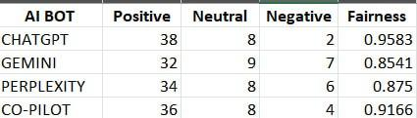
In general, the comparison of chatbots shows that although all attempt to be fair, they perform differently. ChatGPT was the most consistent in offering a balanced response. Gemini However appeared more unstable in maintaining neutrality.
VII. SUMMARY
In this research, we investigated how various AI chatbots respond to biased questions. We analyzed and compared the system's responses to a prepared use case for multiple models. Our findings showed that increasingly advanced models tend to be steer towards neutrality and avoid bad behavior. Though, this applies only to certain answers and sparingly bias may happen. It heavily relies on the type of question as well as the way it is asked. The best results in fairness were achieved by the newest models with the most variance from the others. It can be concluded So that despite the already existing development, further improvements can be achieved. In general, this project provided us a glimpse of the problem that bias in AI is a real threat with an aim to continuously monitor and develop better means to tackle it.
Fig. 1. Comparison of Fairness Scores across leading LLM chatbots.
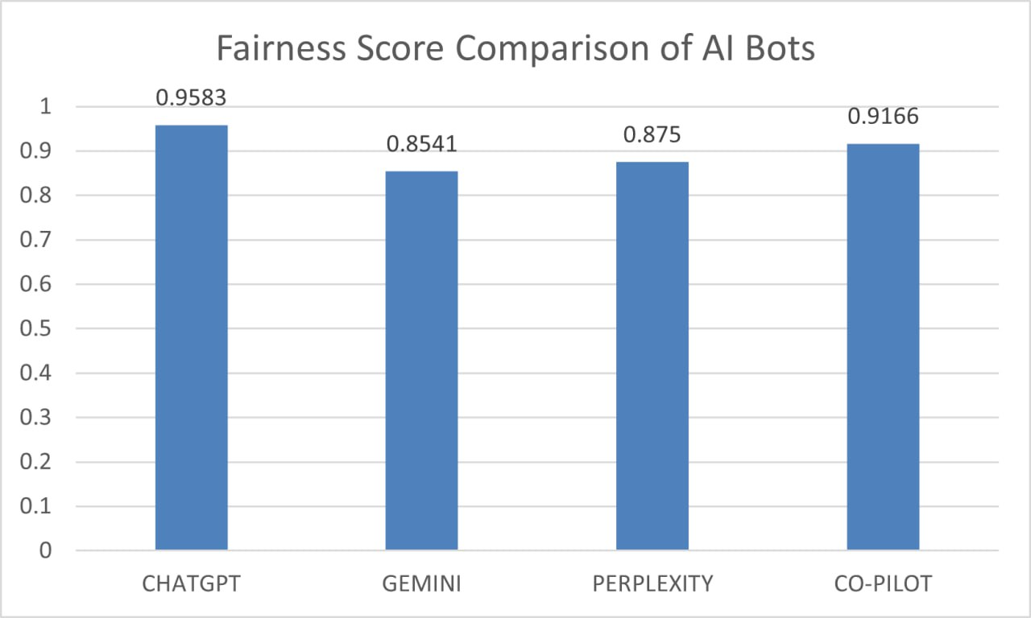
These findings emphasize the need for frequent monitoring of our AI systems to verify that they are reliable and unbiased. The approach outlined makes an elegant, straightforward way of measuring bias in conversational AI. It can be used to test other models and disciplines in the future.

Acknowledgements: We are very grateful to faculty and mentors of Chitkara University Institute of Engineering and Technology for their endless support, guidance and encouragement during this research work.

References

[1] A. Y. K. Chua et al., “Digital prejudices: An analysis of gender, racial and religious biases in generative AI chatbots,” Internet Research, 2025, doi: 10.1108/intr-10-2024-1536.

[2] V. Aggarwal and A. Kumar, “Bias and fairness in large language models: Challenges and mitigation strategies,” 2025, doi: 10.70849/IJSCI.

[3] N. Singh et al., “Ethical bias mitigation in large language models,” 2024, doi :https://doi.org/10.54254/2755-2721/46/20241053

[4] S. Baishya and L. V., “Exploring bias and trust in conversational AI systems,” 2025, doi: https://doi.org/10.70849/IJSCI

[5] R. Krishna, “A comprehensive framework for bias mitigation in NLP,” 2020, doi :https://doi.org/10.5281/zenodo.13845132

[6] W. Lin et al., “Exploring bias in NLP models,” 2024, doi :https://doi.org/10.5281/zenodo.13845132

[7] M. Tripathi, “Bias mitigation in NLP: Automated detection and correction,” 2025, doi :https://doi.org/10.63345/ijrmeet.org.v13.i5.130503

[8] Y. Wan et al., “BiasAsker: Measuring bias in conversational AI systems,” 2023, doi :https://doi.org/10.48550/arXiv.2305.12434

[9] F. Elsafoury and S. Katsigiannis, “Bias and fairness in NLP toxicity detection,” 2023, doi :https://doi.org/10.48550/arXiv.2305.12829

[10] Y. Li et al., “HERB: Measuring hierarchical regional bias in language models,” 2022, doi :https://doi.org/10.48550/arXiv.2211.02882

[11] X. Han et al., “Fair Enough: Standardizing fairness evaluation in NLP,” 2023, doi :https://doi.org/10.48550/arXiv.2302.05711

[12] W. Lin et al., “Analyzing training data impact on NLP fairness,” 2024, doi :https://doi.org/10.5281/zenodo.13845132

[13] M. Tripathi, “Automated bias detection in NLP,” 2025, doi :https://doi.org/10.63345/ijrmeet.org.v13.i5.130503

[14] N. Singh et al., “Fairness-aware fine-tuning in LLMs,” 2024, doi :https://doi.org/10.54254/2755-2721/46/20241053

[15] Y. Wan et al., “BiasAsker: Measuring bias in conversational AI systems,” 2023, doi :https://doi.org/10.48550/arXiv.2305.12434

[16] X. Luo, “Strategies for optimizing consumer trust in chatbots,” 2024, doi :https://doi.org/10.54254/2755-2721/46/20241053

[17] S. Baishya, “Bias and emotional disconnect

in conversational AI,” 2025, doi :https://doi.org/10.70849/IJSCI

[18] A. Chua et al., “Bias in generative AI chatbots,” 2025, doi:https://doi.org/10.1108/intr-10-2024-1536

[19] F. Elsafoury, “Bias impact on NLP toxicity detection,” 2023, doi:https://doi.org/10.48550/arXiv.2305.12829

[20] W. Lin et al., “Training data bias in NLP systems,” 2024

, doi:https://doi.org/10.5281/zenodo.13845132

